ASR 6977

Date: 2018.03.07

To include total completed & total outstanding for

Daily OFI status scanning report

**Request 1: To include total completed & total outstanding for SO**

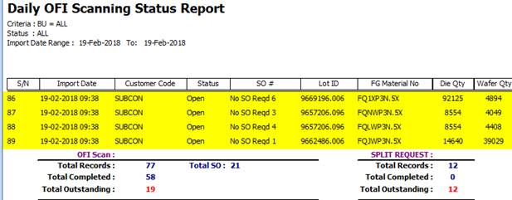

Completed SO:

Outstanding SO:

OFI Scan :

Total SO = Total Completed + total outstanding.

you can refer to the logic in Total SO , ( detail (1) Total Completed and total outstanding) formula

update 20180313

